Họ và tên: Lê Trung Sơn

MSSV: 1810482

LAB 6

1. What is the 48-bit Ethernet address of your computer?

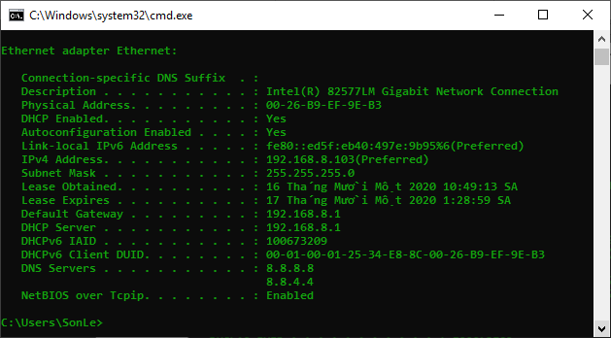

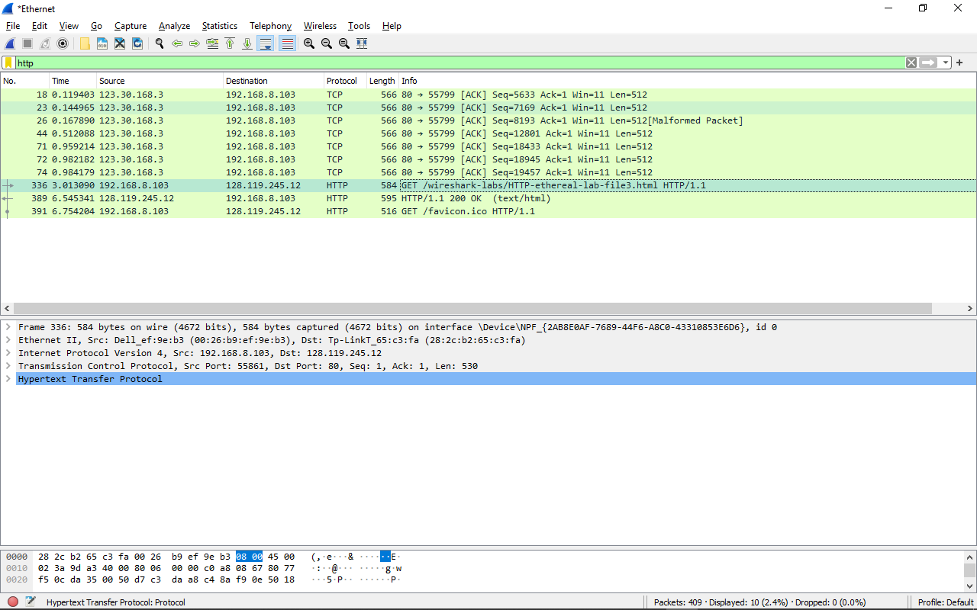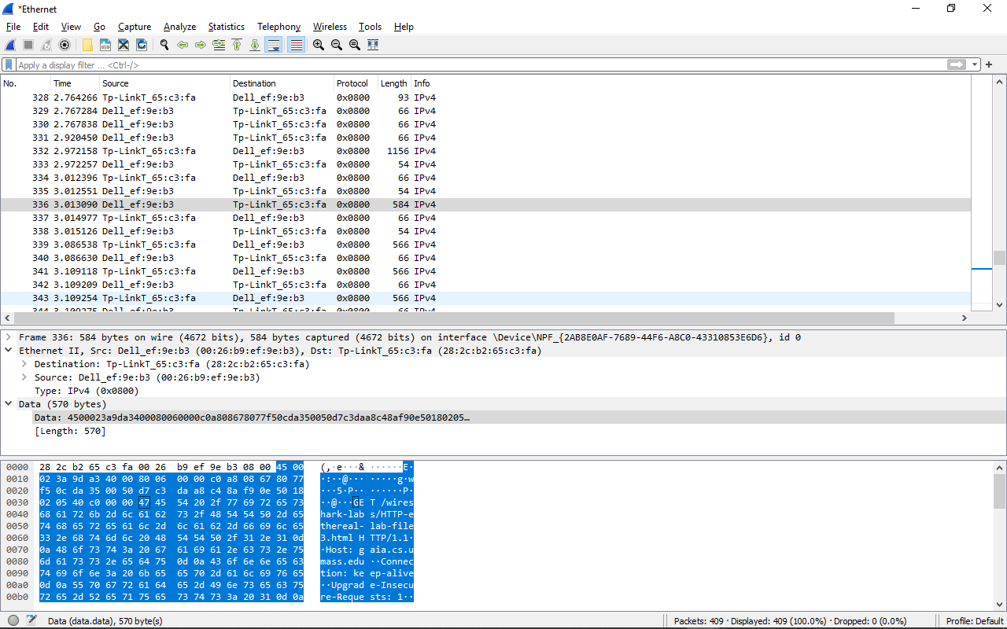

- Source: Dell_ef:9e:b3 (00:26:b9:ef:9e:b3)

2. What is the 48-bit destination address in the Ethernet frame? Is this the Ethernet address of gaia.cs.umass.edu? (Hint: the answer is no). What device has this as its Ethernet address? [Note: this is an important question, and one that students sometimes get wrong. Re-read pages 468-469 in the text and make sure you understand the answer here.]

- Từ trên hình ta thấy Destination: Tp-LinkT_65:c3:fa (28:2c:b2:65:c3:fa)

- Đây không phải địa chỉ của gaia.cs.umass.edu mà là đại chỉ của router mà máy kết nối đến

3. Give the hexadecimal value for the two-byte Frame type field. What upper layer protocol does this correspond to?

- Trong hình trên giá tị là 0x0800, loại là IPv4

4. How many bytes from the very start of the Ethernet frame does the ASCII “G” in “GET” appear in the Ethernet frame?

- Sau 54 bytes, G xuất hiện

5. What is the value of the Ethernet source address? Is this the address of your computer, or of gaia.cs.umass.edu (Hint: the answer is no). What device has this as its Ethernet address?

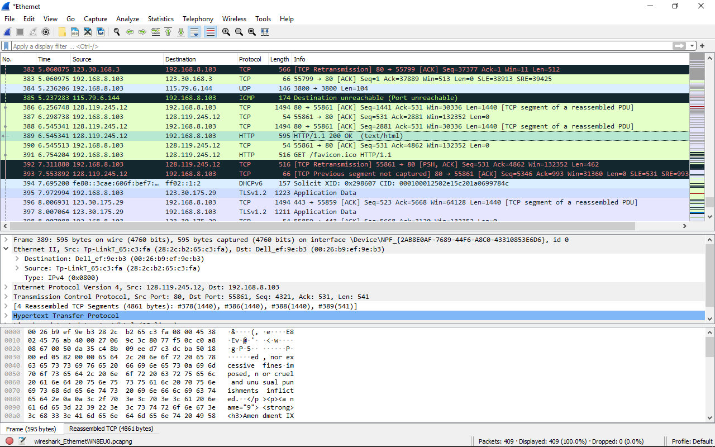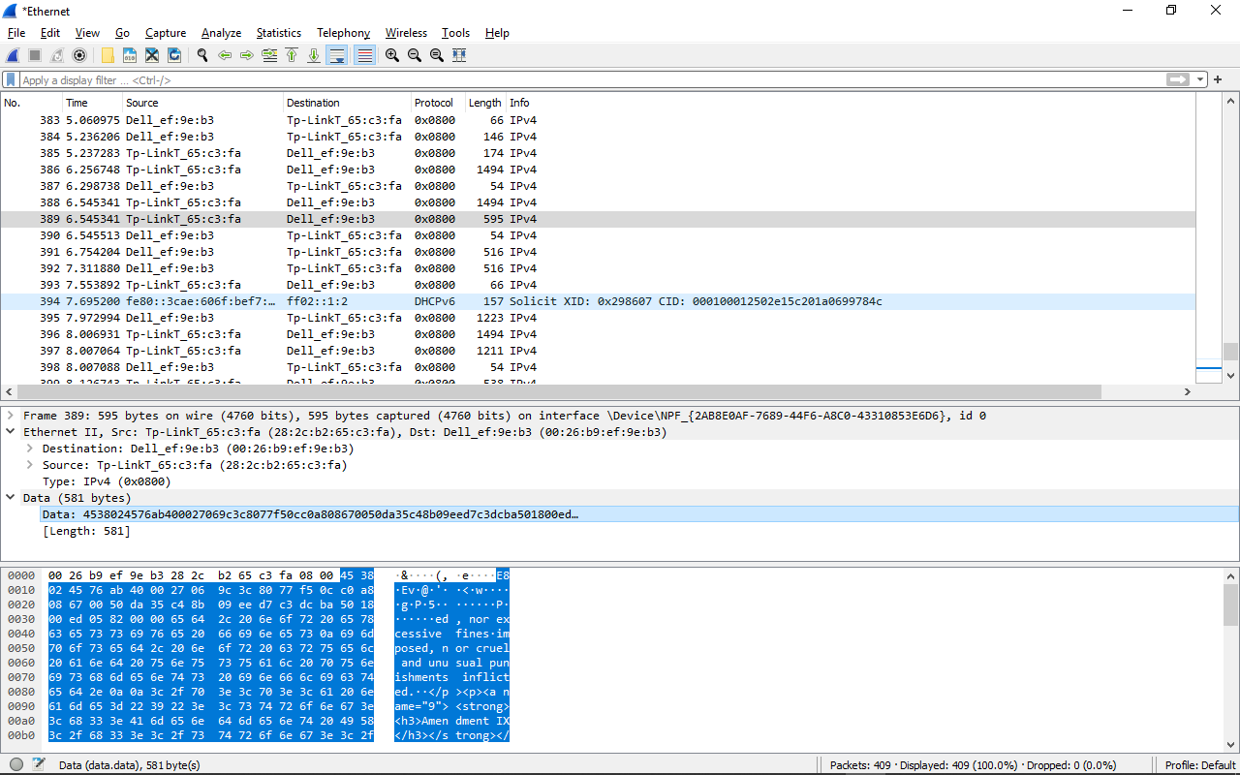

- Source: Tp-LinkT_65:c3:fa (28:2c:b2:65:c3:fa)

- Đây là địa chỉ của router nhận kết nối giữa máy và server phản hồi

6. What is the destination address in the Ethernet frame? Is this the Ethernet address of your computer?

- Destination: Dell_ef:9e:b3 (00:26:b9:ef:9e:b3)

- Đây lại là đại chỉ của máy

7. Give the hexadecimal value for the two-byte Frame type field. What upper layer protocol does this correspond to?

- Trong hình trên giá tị là 0x0800, loại là IPv4

8. How many bytes from the very start of the Ethernet frame does the ASCII “O” in “OK” (i.e., the HTTP response code) appear in the Ethernet frame?

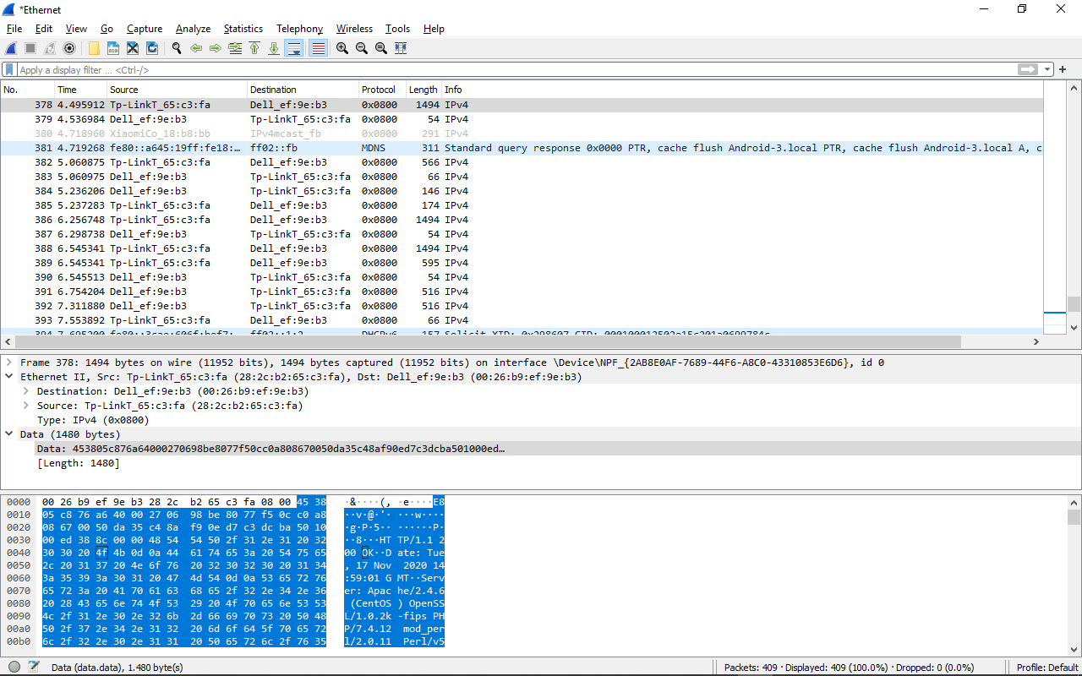

- Theo hình, O xuất hiện sau 67 bytes từ vị trí bắt đầu

9. Write down the contents of your computer’s ARP cache. What is the meaning of each column value?

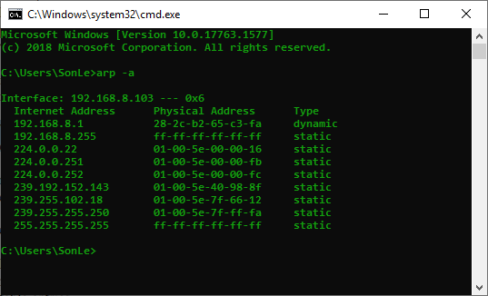

- Cột đầu tiên là địa chỉ IP của máy tính, sau đó là địa chỉ vật lý và cột thứ 3 là loại của nó.

10. What are the hexadecimal values for the source and destination addresses in the Ethernet frame containing the ARP request message?

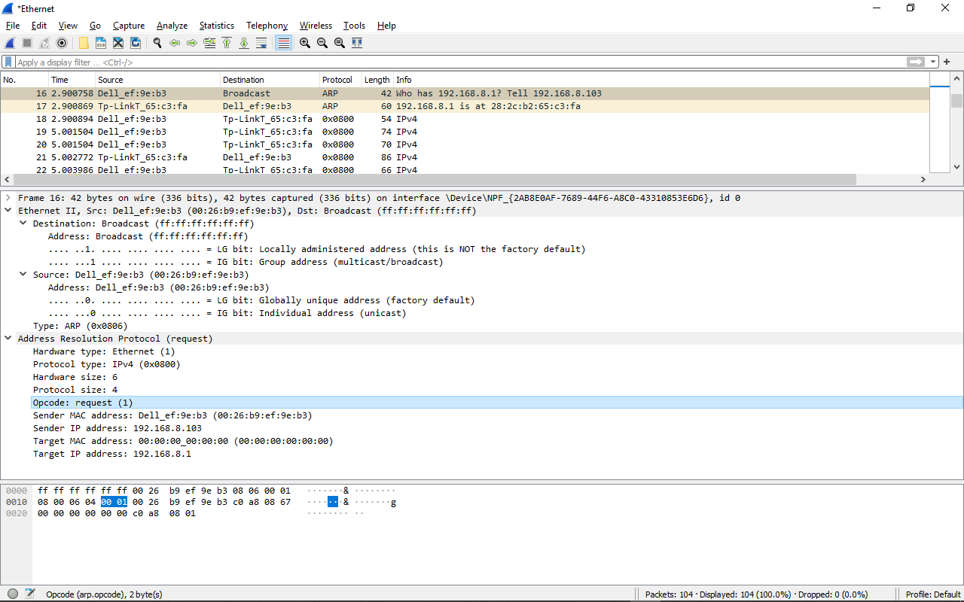

- Source: Dell_ef:9e:b3 (00:26:b9:ef:9e:b3)

- Destination: Broadcast (ff:ff:ff:ff:ff:ff)

11. Give the hexadecimal value for the two-byte Ethernet Frame type field. What upper layer protocol does this correspond to?

- Giá trị là 0x0806 ứng với loại ARP

12. Download the ARP specification from ftp://ftp.rfc-editor.org/in-notes/std/std37.txt. A readable, detailed discussion of ARP is also at http://www.erg.abdn.ac.uk/users/gorry/course/inet-pages/arp.html.

a) How many bytes from the very beginning of the Ethernet frame does the ARP opcode field begin?

- Opcode xuất hiện sau 20 bytes

b) What is the value of the opcode field within the ARP-payload part of the Ethernet frame in which an ARP request is made?

- Opcode có giá trị là 1, loại là request

c) Does the ARP message contain the IP address of the sender?

- ARP message có chứa địa chỉ gửi, IP là 192.168.8.103

d) Where in the ARP request does the “question” appear – the Ethernet address of the machine whose corresponding IP address is being queried?

- Địa chỉ trong “question” nằm trong Target IP address: 192.168.8.1

13. Now find the ARP reply that was sent in response to the ARP request.

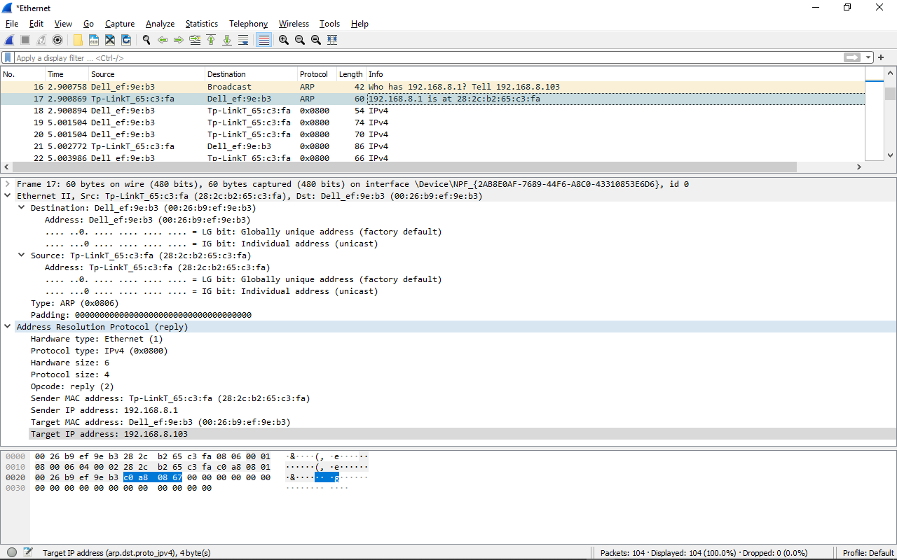

a) How many bytes from the very beginning of the Ethernet frame does the ARP opcode field begin?

- Opcode xuất hiện sau 20 bytes

b) What is the value of the opcode field within the ARP-payload part of the Ethernet frame in which an ARP response is made?

- Opcode có giá trị là 2, loại là reply

c) Where in the ARP message does the “answer” to the earlier ARP request appear – the IP address of the machine having the Ethernet address whose corresponding IP address is being queried?

- “Answer” xuất hiện trong Sender MAC address: Tp-LinkT_65:c3:fa (28:2c:b2:65:c3:fa)

14. What are the hexadecimal values for the source and destination addresses in the Ethernet frame containing the ARP reply message?

- Source: Tp-LinkT_65:c3:fa (28:2c:b2:65:c3:fa)

- Destination: Dell_ef:9e:b3 (00:26:b9:ef:9e:b3)

15. Open the ethernet-ethereal-trace-1 trace file in http://gaia.cs.umass.edu/wireshark-labs/wireshark-traces.zip. The first and second ARP packets in this trace correspond to an ARP request sent by the computer running Wireshark, and the ARP reply sent to the computer running Wireshark by the computer with the ARP-requested Ethernet address. But there is yet another computer on this network, as indicated by packet 6 – another ARP request. Why is there no ARP reply (sent in response to the ARP request in packet 6) in the packet trace?

- Do địa chỉ IP của máy và của ARP request không khớp nhau, do đó máy sẽ không nhận được yêu cầu.